The Iot Based Jacket
Elie Alarou, Atieh Atieh
Notre Dame University – Louaize
North Lebanon Campus – NLC
ECCE – Department
^{ayatieh@ndu.edu.lb}
^{etarou1@ndu.edu.lb}

Abstract— This Project details the design and implementation of a novel IoT-enabled jacket for continuous health monitoring emphasizing the integration of Arduino microcontrollers and specialized sensors. The hardware architecture captures vital health metrics, such as heart rate, oxygen levels, and body temperature, with communication facilitated through HTTPS and socket protocols. The jacket's hardware system is augmented with an Angular-based user interface, providing real-time visualization of health parameters, and facilitating user interaction. Additionally, Node.js serves as the backend, orchestrating seamless connectivity between the wearable device, the frontend, and the database. This work contributes to the field of wearable healthcare technology by providing a comprehensive hardware-software solution, emphasizing the integration of Arduino, specialized sensors, and effective communication protocols. The presented IoT jacket serves as a prototype showcasing advancements in continuous health monitoring systems and their potential impact on user well-being.

- Introduction

The aging population around the world is facing an increasing number of health challenges, with falls and cardiovascular issues being significant contributors to morbidity and mortality among the elderly. In the United States, the impact of falls on the elderly is particularly alarming, as evidenced by the fact that approximately 300,000 elderly individuals are hospitalized annually due to broken hips, a prevalent consequence of falls [1]. Most notably, the financial burden associated with medical costs for broken hips in the U.S. amounts to a staggering six billion dollars per year [2].
The implications of falls extend beyond the immediate physical injuries, as studies have revealed a disturbingly high mortality rate among elderly patients treated for hip fractures. Shockingly, up to 33% of elderly individuals do not survive beyond one year after experiencing a hip fracture, underscoring the severity of the issue [3]. The first 12 months post-hip fracture are especially critical, with one in three adults aged 50 and over dying to the consequences of this injury. Moreover, older adults face a five-to-eight times higher risk of mortality within the first three months of a hip fracture compared to their counterparts without such injuries, and this elevated risk persists for nearly a decade [4].
In addition to the challenges posed by falls, cardiovascular issues pose a significant threat to the well-being of the elderly population. Individuals aged 65 and older are at a heightened risk of experiencing heart attacks, strokes, coronary heart disease, and heart failure [2]. The magnitude of this issue is further emphasized by the fact that, in 2002, heart disease emerged as the leading cause of death among the elderly in the United States, accounting for a staggering 31.8% of mortality [1].

Recognizing the pressing need to address these health concerns among the elderly, our project focuses on the development of an innovative jacket equipped with advanced monitoring capabilities. By integrating features such as heart rate monitoring, fall detection with airbag deployment, blood oxygen level measurement, and temperature monitoring, our project aims to provide a comprehensive solution to enhance the health and well-being of the elderly population. This paper delves into the details of the project, outlining its objectives, design, and potential impact on mitigating the health risks faced by the elderly.

- Standards, Constraints, and Requirements Specification
In the development of the IoT-based Jacket, we have carefully considered various design constraints to ensure the feasibility, ethical soundness, and environmental responsibility of the product. These constraints encompass economic viability, environmental impact, ethical considerations, user safety, social acceptability, and sustainability. From an economic perspective, our primary goal is to create an affordable solution for elderly individuals and their families. To achieve this, we use readily available components like Arduino and sensors to reduce production costs, making the product financially accessible.
Environmental responsibility is a fundamental concern, addressed by using power banks as the primary energy source, reducing the need for disposable batteries. The jacket's design emphasizes energy efficiency and low power consumption to minimize its environmental footprint. User safety is paramount. The jacket includes features like an airbag deployment mechanism to reduce the risk of injury from falls or sudden impacts. Moving on to the project specifications, the IoT-based Jacket aims to ensure the well-being and safety of elderly individuals by continuously monitoring vital signs and environmental conditions. Simultaneously, it aims to provide comfort and peace of mind to wearers and caregivers through advanced functionalities. To achieve our goal of developing an effective healthcare solution for the elderly population, it is important to outline a set of rigorous requirements that will guide the design and implementation of the proposed system. The primary objective of this system is to ensure the well-being and safety of elderly individuals by monitoring their vital signs and environmental conditions. Additionally, the system aims to provide comfort and peace of mind to the elderly wearer and their caregivers through a range of advanced functionalities:
1. Room Temperature Tracking: The system shall monitor ambient room temperature, allowing to maintain a suitable environment for the elderly.
2. Heating function: To ensure the warmth of the elderly using heating pads resistors.
3. Health Parameters Tracking: The system will continuously monitor and report essential health parameters, including:
a. Heart Rate.
b. Blood Oxygen Level.
c. ECG (Electrocardiogram).
d. Body temperature.
4. Fall Mitigation: To reduce the risk of injury from falls, the system shall be equipped with an airbag deployment mechanism that activates in case of a fall or sudden impact.
5. User-Friendly App: providing a dedicated website and mobile application for caregivers to be able to access all the important data, and act when receiving emergent notifications. These specifications constitute the fundamental requirements for the product. By adhering to these requirements, the system will enable caregivers to provide optimal care for elderly individuals, ensuring their safety, comfort, and peace of mind by abiding to the standards set forth by prominent organizations such as the Institute of Electrical and Electronics Engineers (IEEE) and the American Society for Testing and Materials (ASTM).

- Functional Decomposition
At the foundational level (Level 0) of the project system, data is collected from an array of sensors. This data is subsequently channeled to the system's core processing unit for comprehensive analysis and processing. Once this processing is complete, the system generates user-friendly outputs in the form of both a website and a mobile application, ensuring real-time updates and results are readily available.
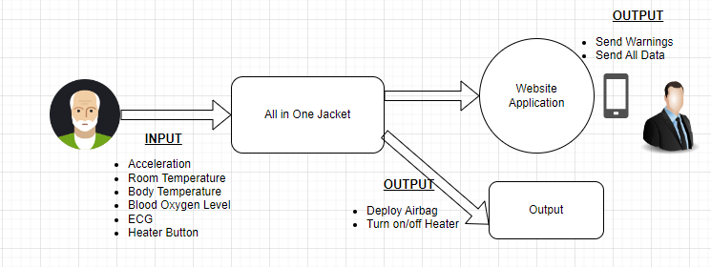
Figure 1: Functional Decomposition Level 0
At a more profound level, the system is composed of an array of sensors integrated with two Arduino/ESP, which will be the main responsible for processing and output generation, in its different forms. Staring with the sensors used:
1. AD8232: Responsible for monitoring ECG and heart rate.
2. MAX30100: Dedicated for the blood oxygen level.
3. MPU6050: Enabling fall detection and ambient room temperature tracking.
4. DS18B20: Accurate measurement of the patient's body temperature.
The Arduino/ESP processors play a central role in processing the collected data. The resulting output is available in multiple forms, enhancing patient care:
1. Website and mobile application.
2. Deploying airbag.
3. Turning on/off the heated sheets.
This integrated system empowers caregivers with a comprehensive monitoring mechanism, providing data-driven insights and enhancing patient safety and comfort.
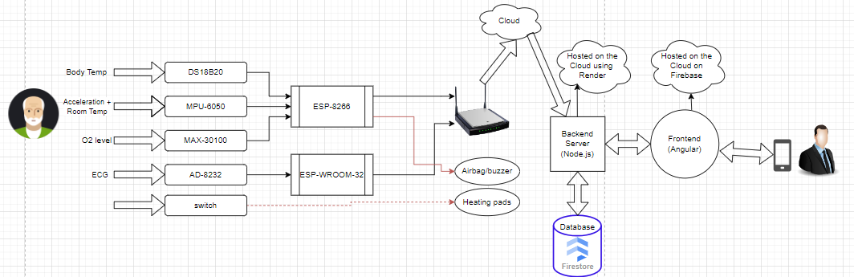
Figure 2: Functional Decomposition Level 1

- Hardware Implementation

We start with the full circuit implementation. As we can see, the sensors are connected to the ESPs. The MAX-30100 and MPU-6050 are both connected to the ESP-8266 using SCL and SDA pins which is the I2C protocol. Each sensor has a different I2C protocol address, which makes the connection feasible. The AD-8232 is connected using two digital pins for L+ and L- and one analog pin for data to the ESP-WROOM-32. The AD18B20 is connected to one digital pin. Additionally, the buzzer, which represents the airbag, is connected to a digital pin used as output. The heating pads, represented as a chunk of resistors, are connected to a power supply and a switch to turn them on and off.

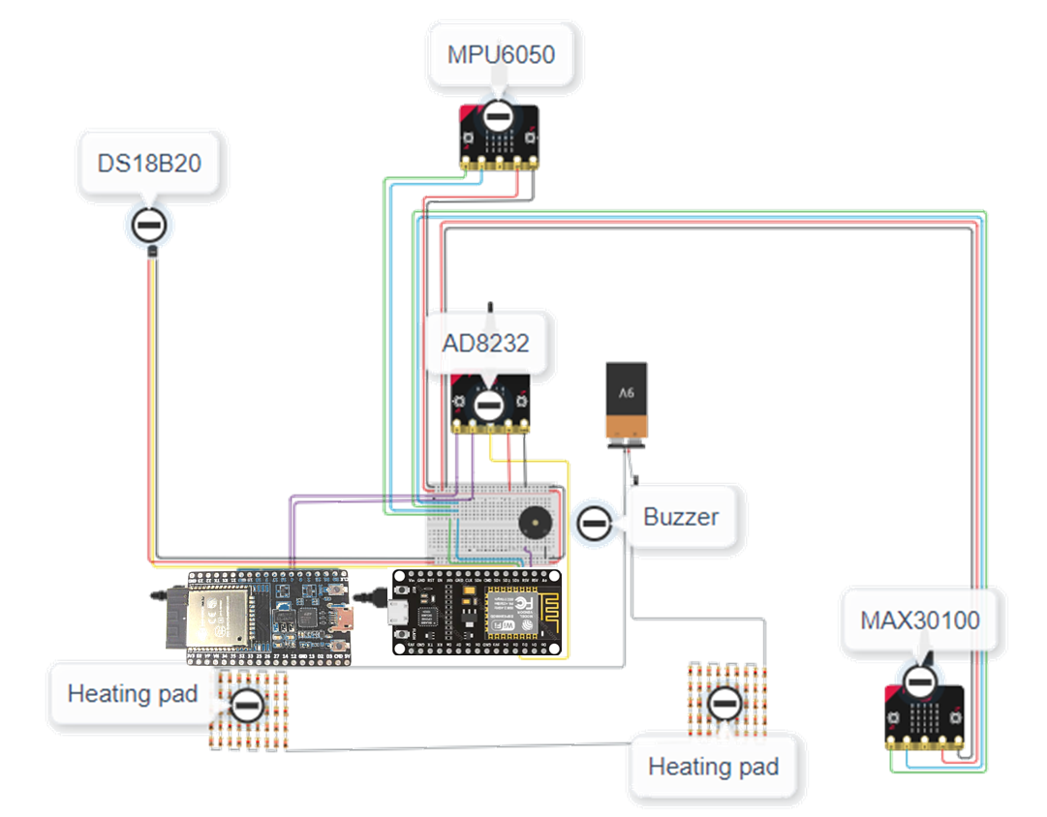
After connecting all the circuit, we dive into the sensor’s implementation. The following picture is the flow chart of the logic in the hardware.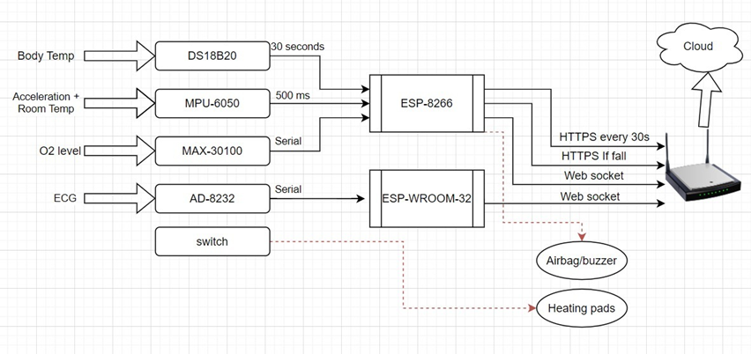

The DS18B20 is sending data every 30 seconds. The ESP-8266 is reading the acceleration every 500 milliseconds and the O2 level serially. After the data is processed, it is sent to the backend using the Wi-Fi connection. The temperatures are sent every 30 seconds using HTTPS, the fall notification is only sent when there is a fall, and the O2 level is sent using WebSocket. In the case of a fall the ESP-8266 will initialize the deployment of the airbag, in our project it is represented using a buzzer.
Now for the ESP-WROOM-32, it is connected to the ECG sensor. The sensor is read serially, and the data is sent directly using web socket. Making sure to calculate the heart rate and send it too.
For the testing part we will dive only in the three sensors O2, fall detection and ECG. Starting with the fall, we started collecting data when there is normal movement and when there is fall and after gathering the data tested multiple thresholds for the acceleration. After huge testing, we chose the threshold to be 6.
In our project the loop for detecting a fall has a duration of 500 milliseconds. In the worst-case scenario, if the fall starts at the starting of the loop, we have a 500-millisecond delay adding to that the delay of airbag deployment that will be discussed next. For testing the airbag is replaced with a buzzer that takes the same signal of an airbag, but it produces a noise.
The delay of deployment of an airbag is around 30 to 50 milliseconds [21]. Adding that to the 500 milliseconds we find that the total fall detection and protection system has a delay of 550 milliseconds.
To find if the delay is acceptable or not let’s take a person if height 165cm and take the worst-case scenario. That is if the person collapses spontaneously, and collapses on the ground directly without the resistance of the feet. We will use the following formula to find the time required before directly hitting the ground.
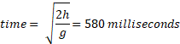

This value is greater than the time required to initiate the fall detection and protection system. In addition, the feet play an important role in slowing down the falling prosses which can get it up to 1 second, adding to that is the person is not fully collapse can help delay the impact.

For the oxygen level, we compared the values with a real pulse oximeter, and we found the error to be around 1%.
For the ECG plot we found this output after correcting the error from the power supply to the ESP. And used this output to calculate the R-to-R interval (the interval between to peaks or heart beats). This interval is used to find the instants heart beat.
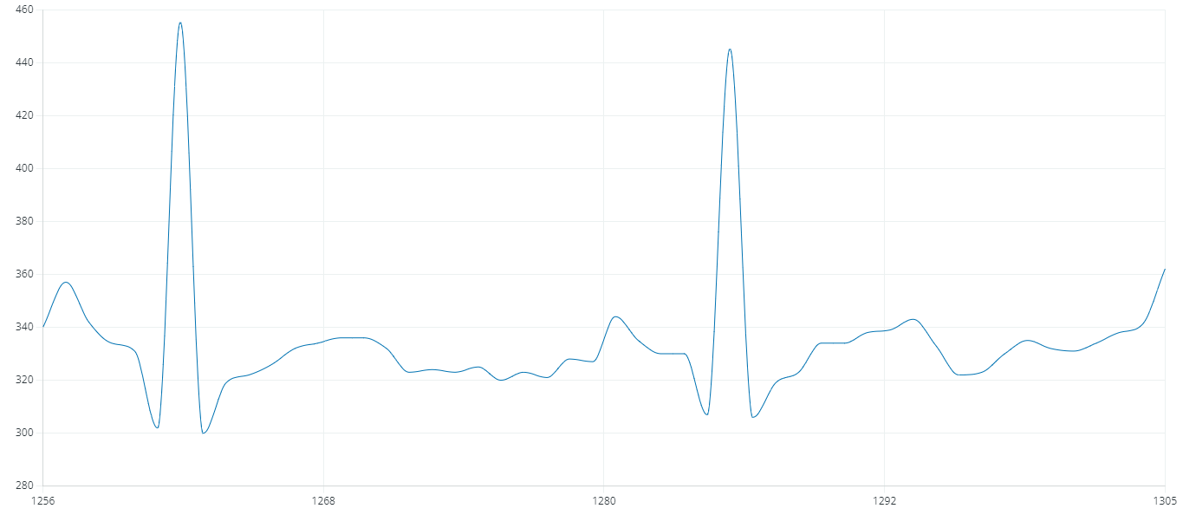

After all the hardware is connected, they are put on the jacket making the user able to wear it.
- Full application
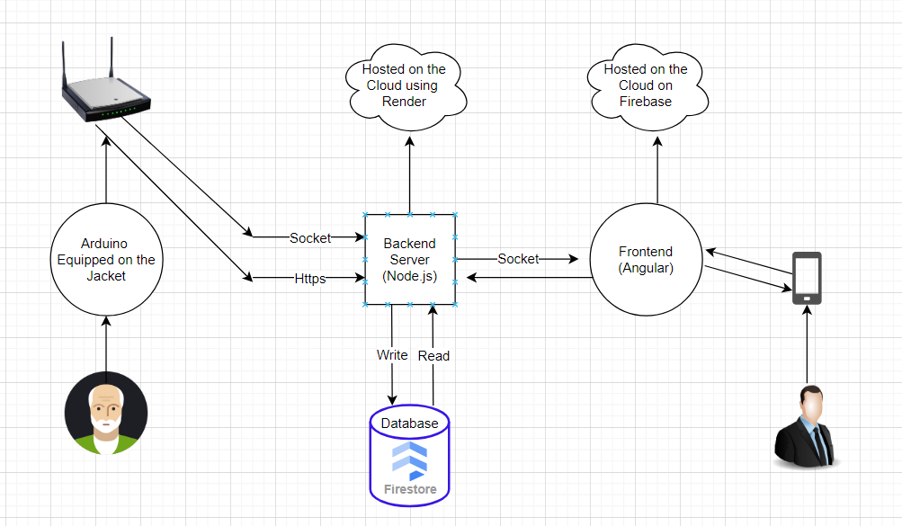
As depicted in the image above, the software is divided into three major components. The Arduino part is responsible for retrieving monitored data from sensors, packaging the data, and transmitting it to the Node.js backend hosted on the cloud using Render. The backend then processes this data and forwards it to the Angular frontend hosted on Firebase, saving relevant information to a Firestore database, also hosted on Firebase.Communication between Arduino and the backend employs two techniques: socket.io and HTTPS POST API, based on the type and sensitivity of the data. For instance, for data like temperature, it suffices to send it once every minute, making a POST request ideal due to the absence of constantly changing data. This method ensures efficient resource utilization. However, for critical data such as heart rate and oxygen levels requiring real-time updates, a live communication channel using sockets is employed. Socket communication enables the instantaneous transmission of sensitive data, ensuring timely and accurate updates on the user's end. This approach simplifies the process of Arduino data transmission, eliminating synchronous delays associated with every HTTPS POST request. Given that Arduino is not asynchronous, continuously sending updates, for instance, every second for oxygen levels, could negatively impact the system's performance. Now we will show all the applications features:
Real-time Monitoring:
Display and update oxygen level, heart rate, body and room temperature on an Angular-based user interface.
- ECG Visualization:
  - Continuously update an ECG graph using an API that fetches ECG data points from the backend.
- ECG Data Management:
  - Trigger an API from the frontend to save ECG data locally and on the cloud by storing points in the database.
- View Saved ECGs:
  - Retrieve and display all saved ECGs through an API, allowing users to choose and view specific records.
- Fall Detection:
  - Detect falls using MPU gyroscope on Arduino.
  - Send an HTTPS request to the Node.js backend upon fall detection.
- Emergency Notification:
  - Use an API to fetch subscribers for notifications.
  - Send an emergent notification to the Angular PWA web app.
- Fall History:
  - Allow users to choose date ranges to check the falls of the person using an API that returns the date and time of falls.
All of these features are created internally as api’s, on the backend side and called through an array of api’s by angular that is used to provide an appealing UI/UX experience.
Backend APIs:
- Send Sensor Data:
  - Receive temperature, oxygen, and heart rate, ecg points data from Arduino through HTTPS POST requests.
  - Present this data beautifully in the Angular UI.
- ECG Data Update:
  - Continuously send ECG data points to Angular for live graph updates.
- Save ECG Data:
  - Accept a trigger from the frontend to save ECG data points locally and on the cloud in the database.
- Retrieve and Display ECGs:
  - Provide an API to retrieve and display all saved ECGs for user selection.
- Fall Detection Notification:
  - Utilize an API to send emergency notifications to the Angular PWA web app upon fall detection.
- Fall History Query:
  - Offer an API that allows users to query fall history based on selected date ranges.
In summary, the IoT-based Jacket system ensures real-time monitoring of vital signs, provides comprehensive ECG functionality with data management capabilities, detects and notifies falls, and allows users to review fall history within specified date ranges. The system is designed for simplicity, user-friendliness, and efficiency, integrating seamlessly with both the Arduino hardware and Angular frontend. Below are some pictures of the application in use:
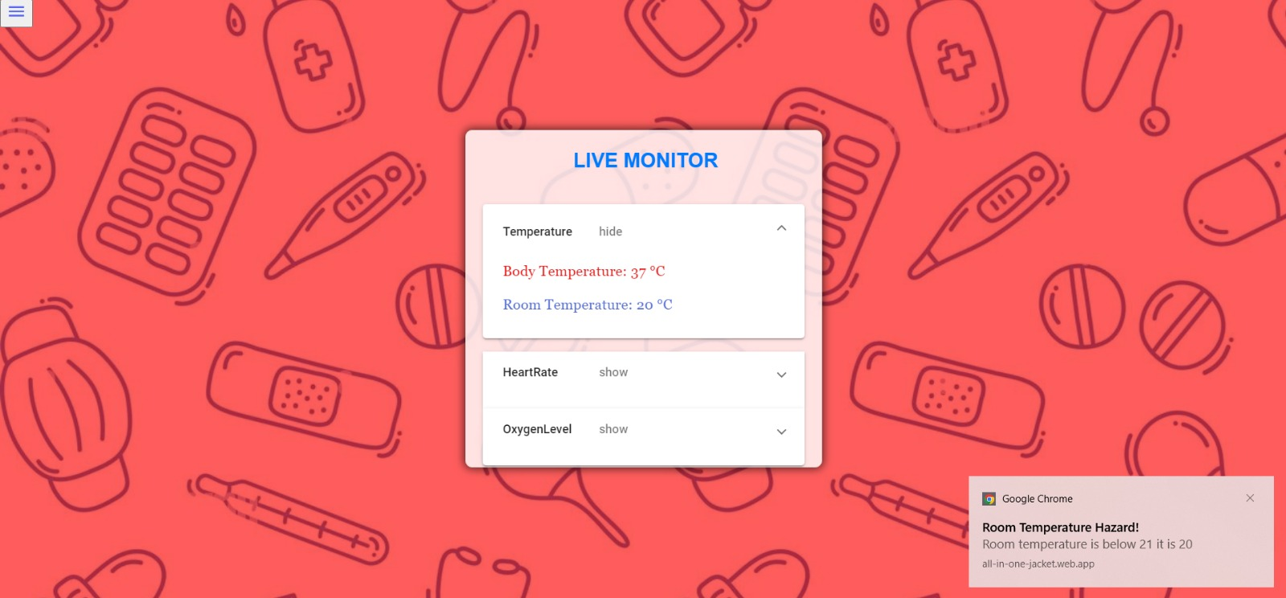
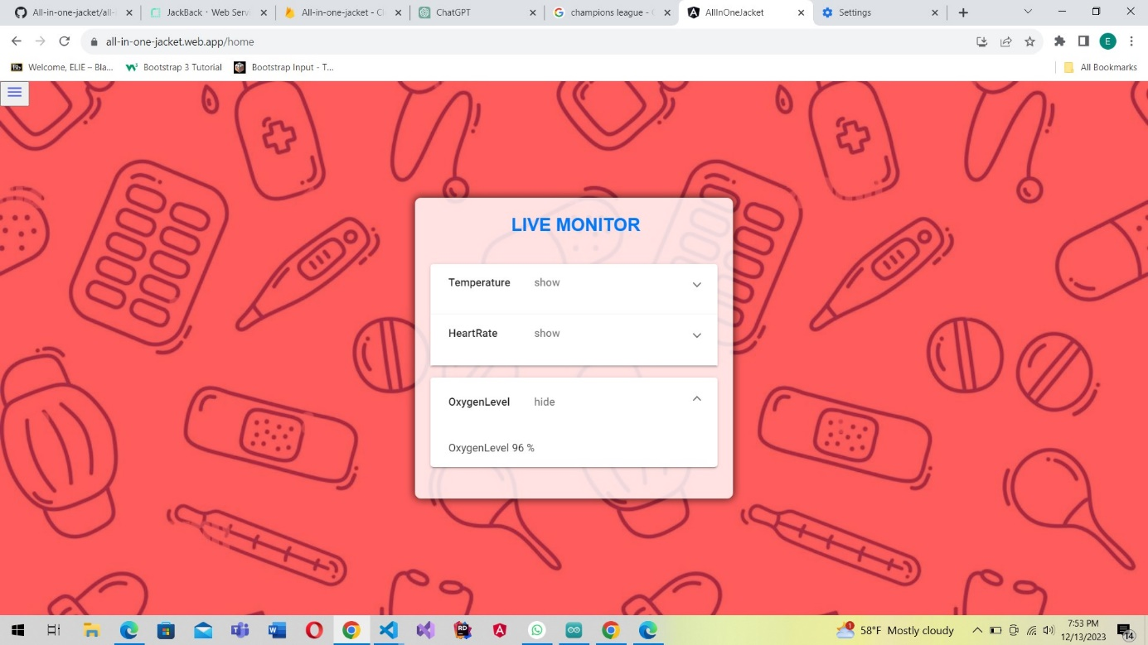

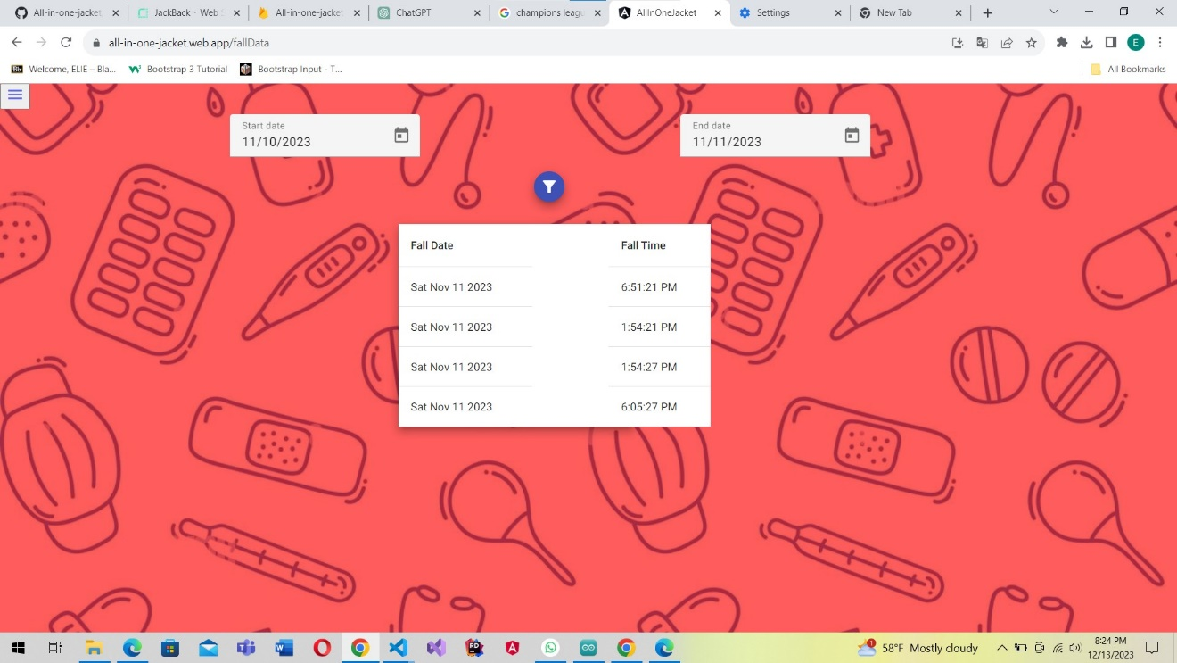

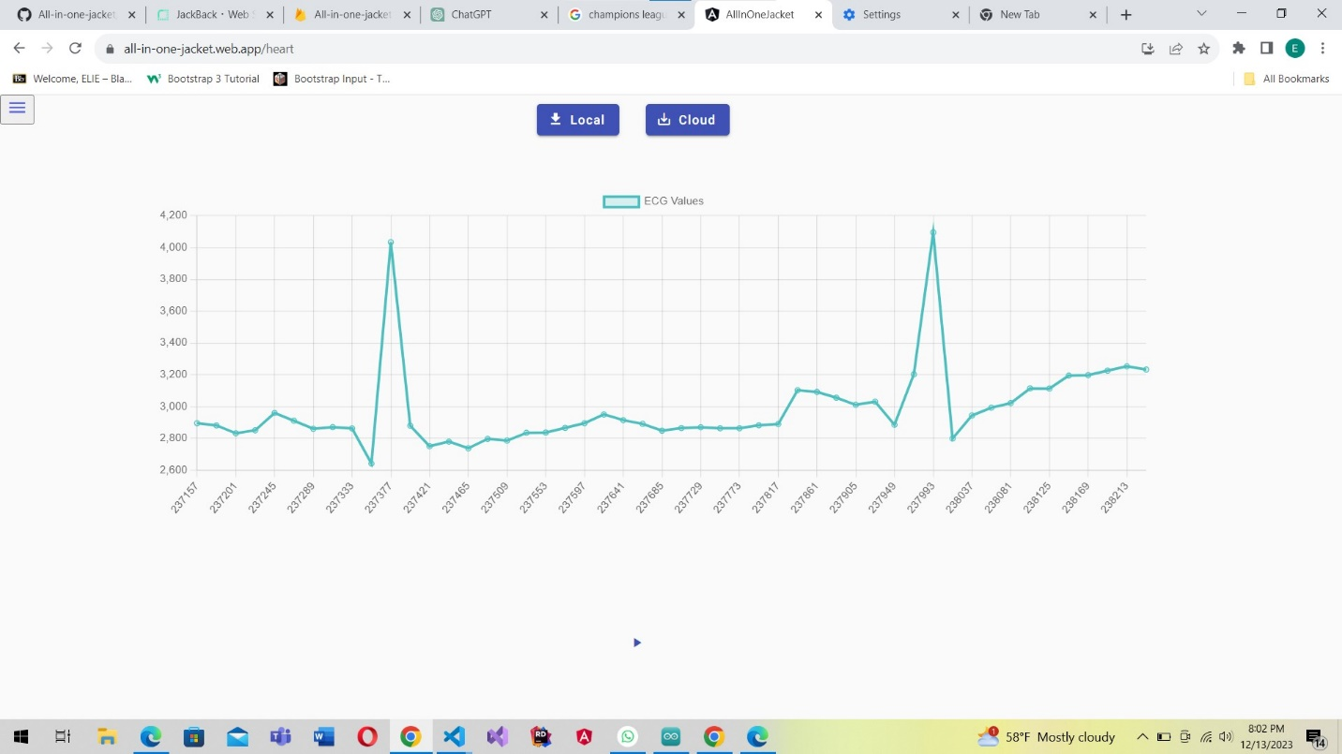

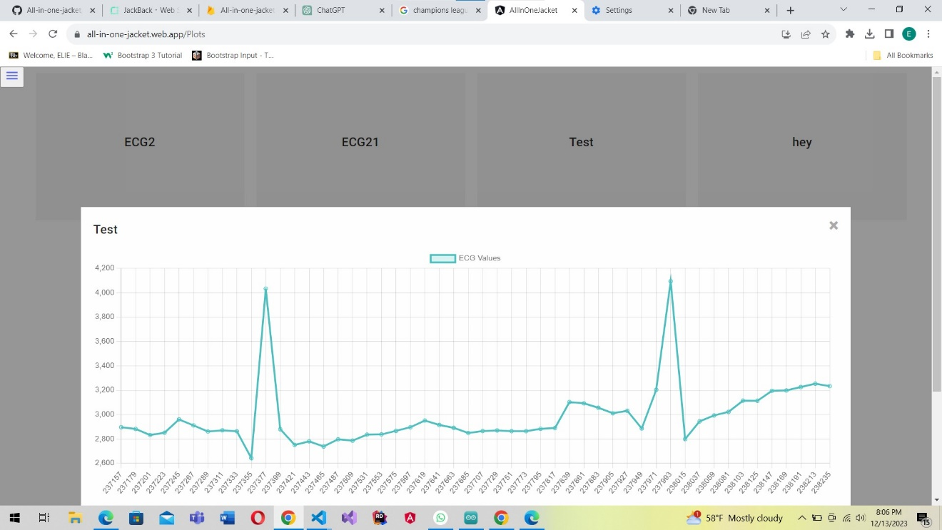

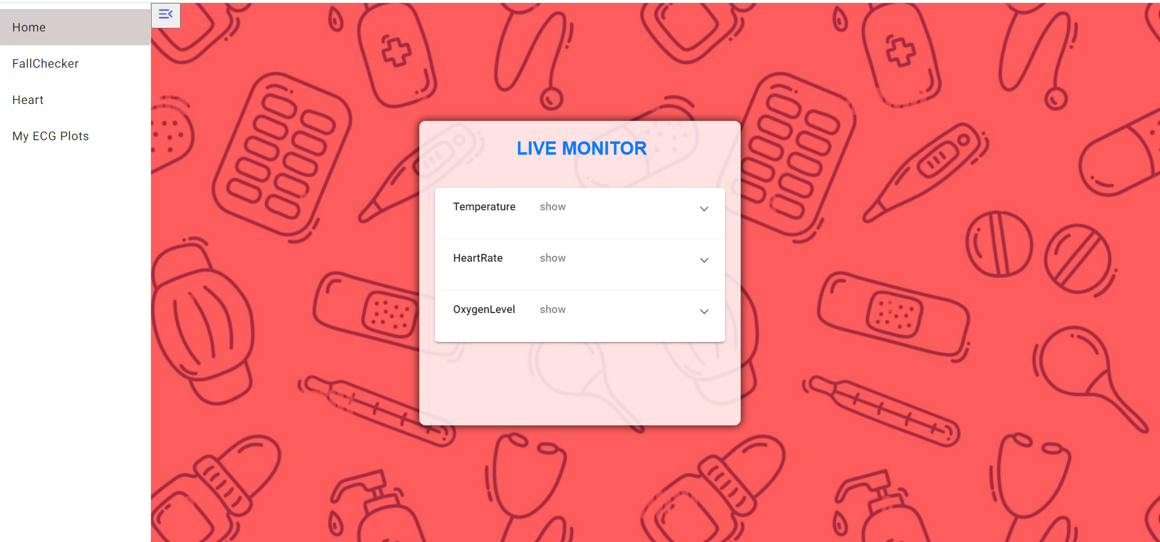

- conclusion
In conclusion, the IoT jacket project represents a significant advance in the usage of technology to enhance the safety and well-being of our elderly population. Through innovative combination of multiple IoT sensors and real-time monitoring, this project not only addresses the critical issue of fall detection but also showcases the potential of IoT in revolutionizing healthcare for seniors. By the integration of technology into everyday life, we pave the way for proactive and immediate response, allowing seniors to live independently with an added layer of security and peace of mind for them, for their relatives, and their healthcare professionals.
References

- Centers for Disease Control and Prevention, "Hip Fractures Among Older Adults," [Online]. Available: https://www.cdc.gov/falls/hip-fractures.html.
- A. J. Burge et al., "The cost of hip fracture in Canada: a population-based analysis of health care utilization and outcomes," Canadian Journal of Surgery, vol. 62, no. 2, pp. 113-120, Apr. 2019. [Online]. Available: https://www.mybib.com/tools/ieee-citation-generator
- D. C. Schairer et al., "The Association of Daily Physical Activity and Mortality After Hip Fracture," American Journal of Epidemiology, vol. 170, no. 10, pp. 1290-1296, Nov. 2009. [Online]. Available: https://www.scribbr.com/citation/generator/ieee/
- S. Scutti, "Hip fracture risk may be heightened by partner's death," CNN, May 13, 2019. [Online]. Available: https://edition.cnn.com/2019/05/13/health/hip-fracture-death-partner/index.html.
- Components101, "NodeMCU ESP8266 Pinout, Features and Datasheet," [Online]. Available: https://components101.com/development-boards/nodemcu-esp8266-pinout-features-and-datasheet.
- Components101, "ESP32 DevKitC Pinout, Overview, Features & Datasheet," [Online]. Available: https://components101.com/microcontrollers/esp32-devkitc.
- Tricog, "12-Lead ECG vs Single Lead ECG," [Online]. Available: https://www.tricog.com/12-lead-ecg-vs-single-lead-ecg
- ElProCus, "AD8232 ECG Sensor Working and Its Applications," [Online]. Available: https://www.elprocus.com/ad8232-ecg-sensor-working-and-its-applications/.
- [Analog Devices, "AD8232 Heart Rate Monitor Front End Data Sheet," [Online]. Available: https://www.analog.com/media/en/technical-documentation/data-sheets/ad8232.pdf.
- Circuit Digest, "Understanding ECG Sensor and Program AD8232 ECG Sensor with Arduino to Diagnose Various Medical Conditions," [Online]. Available: https://circuitdigest.com/microcontroller-projects/understanding-ecg-sensor-and-program-ad8232-ecg-sensor-with-arduino-to-diagnose-various-medical-conditions.
- The Physiologist, "The ECG Leads, Polarity and Einthoven’s Triangle," [Online]. Available: https://thephysiologist.org/study-materials/the-ecg-leads-polarity-and-einthovens-triangle
- Analog Devices, "AD8232 Heart Rate Monitor Front End Product Overview," [Online]. Available: https://www.analog.com/en/products/ad8232.html#product-overview
- NHS Blood and Transplant, "Functions of blood: transport around the body," [Online]. Available: https://www.blood.co.uk/news-and-campaigns/the-donor/latest-stories/functions-of-blood-transport-around-the-body/
- Cleveland Clinic, "Hypoxemia," [Online]. Available: https://my.clevelandclinic.org/health/diseases/17727-hypoxemia.
- Robocraze, "How to use MAX30100 Arduino as Heart Rate Sensor," [Online]. Available: https://robocraze.com/blogs/post/how-to-use-max30100-arduino-as-heart-rate-sensor.
- Last Minute Engineers, "MAX30100 Pulse Oximeter and Heart-Rate Sensor Module for Arduino," [Online]. Available: https://lastminuteengineers.com/max30100-pulse-oximeter-heart-rate-sensor-arduino-tutorial/.
- Joy-IT, "SEN-MPU6050," [Online]. Available: https://joy-it.net/en/products/SEN-MPU6050.
- Dallas Semiconductor, "DS18B20 Programmable Resolution 1-Wire Digital Thermometer Data Sheet," [Online]. Available: https://www.alldatasheet.com/datasheet-pdf/pdf/58557/DALLAS/DS18B20.html.
- Katranji, "Katranji Hand Center," [Online]. Available: https://www.katranji.com/item/448739.
- Apidog, "Socket.IO vs WebSocket," [Online]. Available: https://apidog.com/articles/socket-io-vs-websocket/.
- Ritza, "How fast does an airbag deploy and other questions about airbags," [Online]. Available: https://ritza.co/articles/gen-articles/how-fast-does-an-airbag-deploy-and-other-questions-about-airbags/

- Cardinal Health, "Localized Temperature Therapy White Paper," [Online]. Available: https://www.cardinalhealth.com/content/dam/corp/web/documents/whitepaper/cardinal-health-localized-temperature-therapy%20White%20Paper.pdf
- [ASUS and Innodisk: A Partnership for the Future of AIoT](^1^), InnoNews, vol. 3, no. 2, Nov. 2020. [Online]. Available: https://www.innodisk.com/epaper/innonews/202011-asus-and-innodisk/eng.html
- [ Bergen, Gwen, Mark R. Stevens, and Elizabeth R. Burns. "Falls and fall injuries among adults aged≥ 65 years—United States, 2014." Morbidity and Mortality Weekly Report 65.37 (2016): 993-998.

